

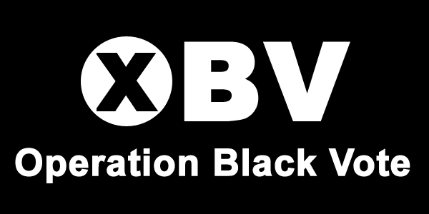



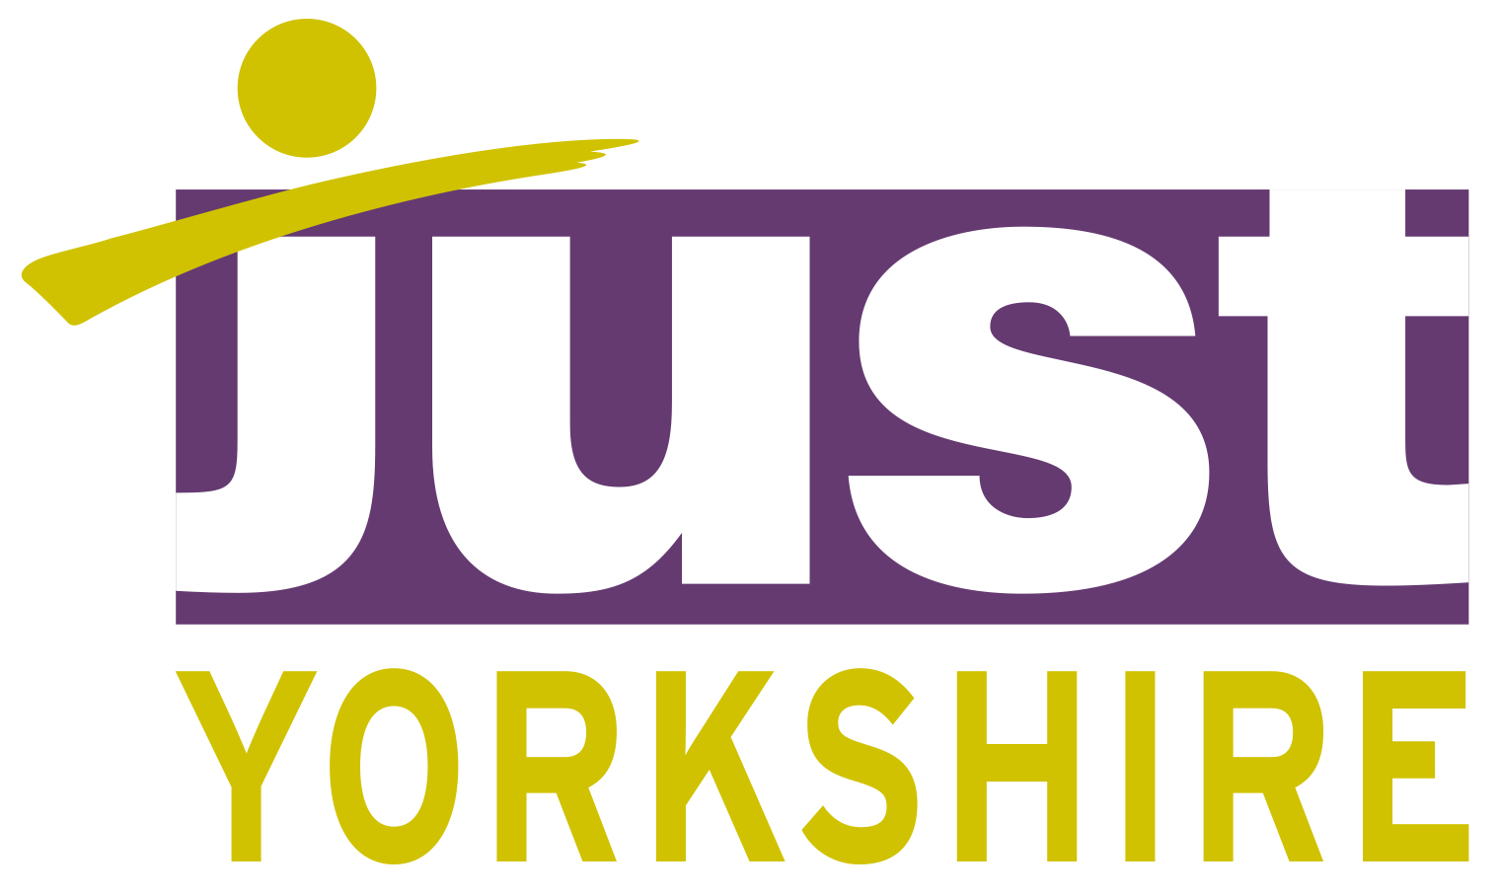

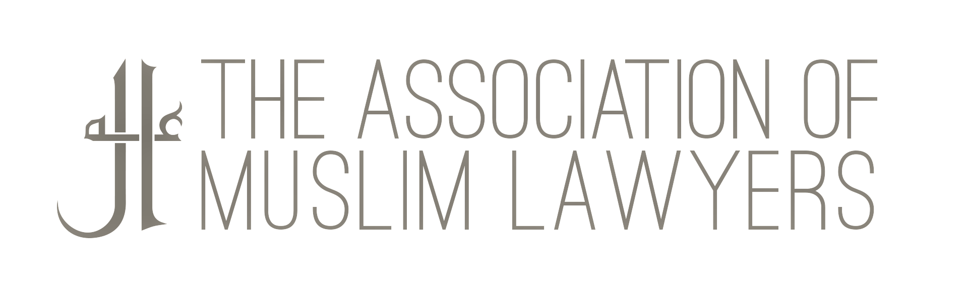



Sir Martin Moore-Bick
The Royal Courts of Justice,
The Strand,
London WC2A 1LL

Via Email only to:
solicitor.enquiries@grenfelltowerinquiry.org;
contact@grenfelltowerinquiry.org;

21 July 2017

Dear Sir Martin-Moore Bick,

Thank you for your letter of 12 July 2017, in response to our letter of 9 July 2017.

Since then, we have, inter alia, undertaken ongoing community and stakeholder engagement. Our BMELawyers4Grenfell group held a further meeting at the Law Society 17 July 2017 which was attended by several major law firms engaged by survivors and families, community representatives and volunteers and Grenfell Legal Support who are working in partnership with us. We have also engaged in a meeting at City Hall 18 July attended by the Mayor’s equality adviser, Matthew Ryder Q.C.

We have also of course held our human rights seminar at the BBC, hosted by the BBC Black and Asian Forum (BBAF) last night, to which we invited you but you declined on the basis that you were holding two meetings with the local communities. Mr James Narey, your Inquiry civil servant responsible for ‘community engagement’ attended part of the seminar. Members of our group were present at your community meeting this evening.

We were pleased to note in your reply of 12 July 2017 that you agree that engaging with and understanding the needs of the community and survivors is a central part of the Inquiry. Unfortunately, there was extremely concerning feedback from survivors and members of the community following your community meeting yesterday morning. Those concerns centred on the fact that the meeting focused very heavily on the technical issues surrounding your Inquiry with what was perceived as little interest in the concerns of the community. This resulted in huge distress which was vocalised last night. Sadly, community concerns have been compounded by the meeting this evening.

Our ongoing engagement, the meeting last night and your community meeting this evening has, inter alia, uncovered extreme concern about continuing and chaotic failures on the ground to provide consistent advice from allocated social workers, family liaison officers and others working for the various local authorities under ‘Gold Command’, exacerbating trauma, stress and anxiety. Whilst Gold Command may not fall within your remit, the constant and often distressing struggles that members of the community are facing, on a daily basis, impacts directly on their ability to engage with your community meetings and for you to obtain the best input possible. This already extremely traumatised community is effectively being disabled from effective engagement. How is that expected to assist your Inquiry?

A further key concern voiced on a number of occasions last night was the lack of ethnic, cultural, linguistic and religious diversity in your own Inquiry team. The lack of consultation prior to each stage of the Inquiry process and the lack of openness and transparency at every stage in the appointment process have, and will continue to, affect confidence. The fact that no one was able to affirm tonight that they were at all familiar with section 149 of the Equality Act 2010 was, quite frankly, shocking. It may be apposite to highlight certain factors herein for your benefit:

The Public sector duty under section 149 came into force April 2011and public authorities like the Ministry of Justice are now required, in carrying out their functions, to have due regard to the need to achieve the objectives set out under s149 of the Equality Act 2010 to:
- eliminate discrimination, harassment, victimisation and any other conduct that is prohibited by or under the Equality Act 2010;
- advance equality of opportunity between persons who share a relevant protected characteristic and persons who do not share it;
- foster good relations between persons who share a relevant protected characteristic and persons who do not share it.
Further, to ensure transparency, and to assist in the performance of this duty, the Equality Act 2010 (Specific Duties) Regulations 2011 require public authorities, to publish information to demonstrate their compliance with the public sector equality duty.
We acknowledge the time for submission of TOR has now been extended to 4th August. We will of course submit our substantive submissions on terms of reference, the lack of diversity and expertise of the Inquiry team, the necessity for a diverse panel of advisers with suitable skills, and terms for the conduct of the Inquiry process by that date.

However, as a direct result of our work we urgently request that you organise a consultation meeting before the 4th August deadline, targeted at the lawyers representing families, the mental health professionals, and the charities that are directly involved in supporting survivors and their families.

A separate meeting in central London where non-technical professionals can make their oral submissions before the 4th August is essential if you are to hear a comprehensive assessment of how your Inquiry should approach the Terms of Reference, your composition and procedure for conducting the Inquiry itself. Many of those involved in our voluntary organisation have substantial first hand experience of the establishment of the McPherson Inquiry and others, of giving evidence before it and other Inquiries and ensuring that recommendations were implemented subsequently. We are not motivated by any fiscal or other form of reward. We simply want justice. And justice must be seen to be done.

There is an urgent need to establish trust and confidence in every aspect of this Inquiry. Sensitive and continued consultation with those directly affected is a key part of that process.

We have the advantage of learning from the lessons of Hillsborough and the Child Abuse Inquiry that full consultation is an essential part of any Inquiry. We believe that as Chair of the Inquiry you would find this a mutually beneficial experience. It is essential that we work to build trust and confidence in the Inquiry at the earliest opportunity. Meeting those professionals who continue to work closely with the diverse community and survivors is a central part of that process. None of the survivors, families, members of the community or the voluntary organisations wish to bring judicial review proceedings but, if they continue to be ignored, and openness and transparency continue to be flouted, they will have little choice but to proceed down that avenue.

We look forward to hearing from you at the earliest opportunity

Regards,

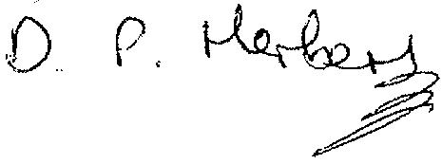

D Peter Herbert O.B.E. (SBL) & Mrs Ismet Rawat President of (AML)
On behalf of the undersigned groups.

The Society of Black Lawyers (SBL)
The Association of Muslim Lawyers (AML)
BLAKSOX
The British Nigerian Law Forum (BNLF)
The Society of Asian Lawyers (SAL)
The Black Solicitors Network (BSN)
Black Activists Rising Against Cuts (BARAC) UK
Operation Black Vote
The Association of Black Probation Officers

CC The Prime Minister, the Honourable Theresa May M.P.
Cc The Home Secretary, Amber Rudd M.P.
Cc The Lord Chief Justice, Lord Thomas of Cwmgiedd

